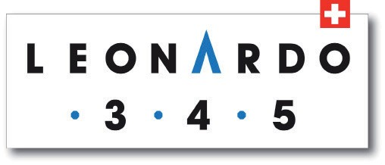

Enrolment Form
Leonardo3.4.5 Training & Accreditation

Accreditation date 2022 7 & 8 April

Name: ……………………………......................... First Name: ………………………………………
Profession/Company: ...………………………………………………………..……………………............
Address: ……………………………………………………………..………………………………….….... Post Code: ………………………………….....
Town: ……………………………………………….…… Country: ……………………........................................................................…
Tel: ………………………E-mail: ………………………….………….……

Training Cost:
€2,400 excl VAT
Payment in full is expected to be paid before the start of the seminar to the following account with the communication “Leonardo345 Accreditation NAME SURNAME DATE”
IBAN: BE77 0689 0433 2542

I accept the practical and financial conditions of International Consulting Expertise EEIG

Date : …………………………… Signature : ……………………………………………………………………………………………………

This registration form should be returned by post to the address below or by e-mail to: contact@leonardo345.be

LEONARDO345 BENELUX, 150 Chaussée de la Hulpe, 1150 Brussels
T. +32 3 544 74 51
www.leonardo35.be contact@leonardo345.be

